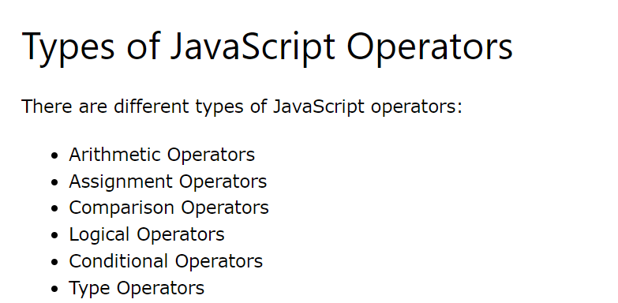

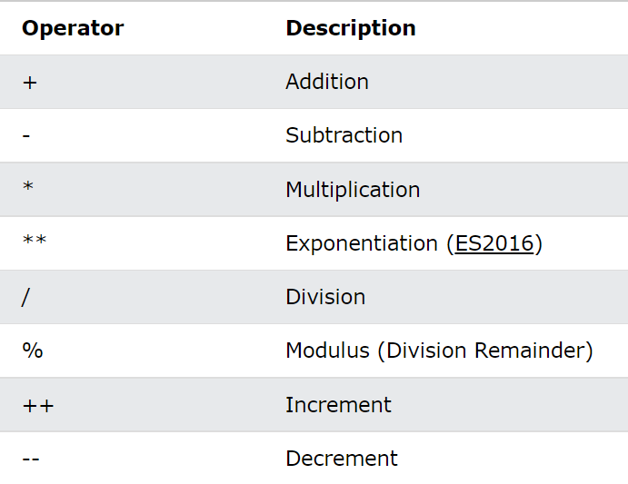
Arithmetic Operators

Assignment Operators

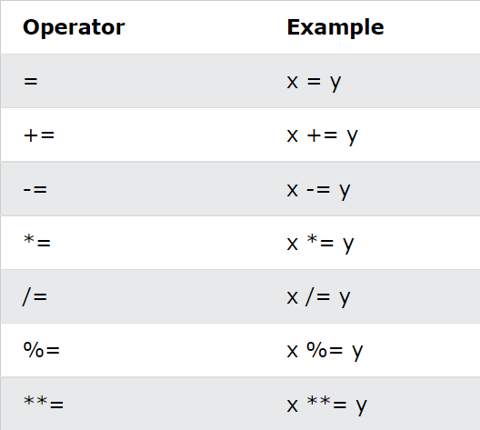
String Operators
+ operator to concatenate strings

Comparison Operators
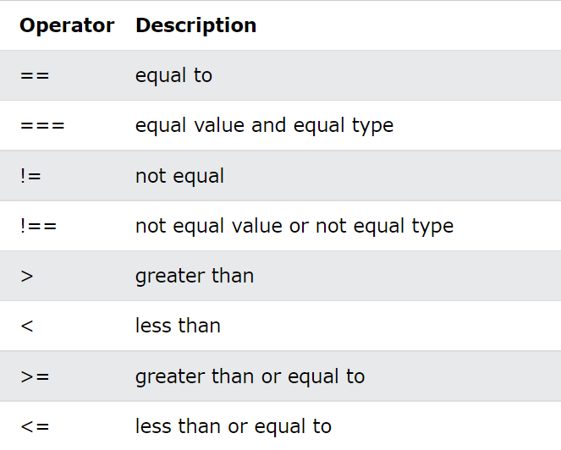

Logical Operators

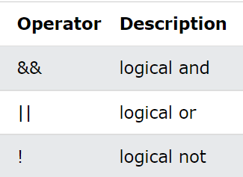
Logical Operators



Type Operators
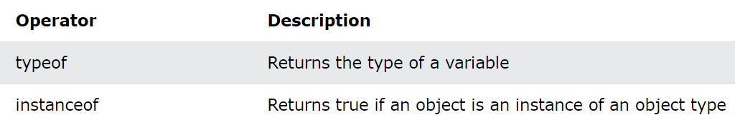

Ternary Operators
?: = (condition)?true:false;

